Norfolk County Council proposes to make a Temporary Traffic Regulation Order (the “Order”) (STRO14416a) affecting the U76598 Jays Green from its junction with U76262 School Lane for 200 metres westwards (“Road A”), U76598 Candlers Lane from its junction with Redenhall Road for 100 metres southwards (“Road B”) and C363 Station Road from its junction with Millers Green for 30 metres southwards (“Road C”) in the Town of Redenhall with Harleston to facilitate gas main replacement works, the Roads A-C will be temporarily closed/restricted (except for pedestrian access) for the duration of the works/period the closure is necessary which is anticipated to be from 6th April to 22nd May 2026, but may continue to be closed/restricted until the 22nd November 2026 where the closure/restriction is still required beyond the anticipated dates.

NB: Please note the works will be carried out in phases – Road A is anticipated to be closed between 6th to 17th April 2026, Road B is anticipated to be closed between 20th April to 1st May 2026 and Road C is anticipated to be closed between 4th to 22nd May 2026.

Alternative route is via: A) Mendham Lane, Old Market Place, Church Street, The Thoroughfare, Redenhall Road, Broad Street, School Lane. Access to Candlers Lane from Redenhall Road up to the points of closure. Access to Briar Road from Mendham Lane up to the points of closure. B) Redenhall Road, School Road, Jays Green. C) Station Road, Station Hill, Gawdy Lane, Hallwong Lane, Redenhall Road.

The works promoter for this restriction/closure is: Cadent.

Vehicular access will be permitted to a final destination in the Roads A-C where signs indicating such access is possible and permitted are in place.

The Order shall automatically revoke on the completion of the works/when the closure is no longer necessary or otherwise on the 22nd November 2026 without further notice.

If necessary, the restriction could run for a maximum period of 18 months from the date the Order is effective.

A person who contravenes, or who uses or permits the use of a vehicle in contravention of the restriction/closure imposed by the Order shall be guilty of an offence.

Penalty: £1000 maximum fine on conviction and/or endorsement for contravention.

In the event of the start date being delayed the new start date will be displayed on site in advance.

Full details on the closure are available at https://one.network. Any enquiries that cannot be answered on the one.network website should be directed to the South Area Streetworks (Infrastructure Department) contactable by telephone at 0344 800 8020 or email at streetworks@norfolk.gov.uk

Dated this 27th day of March 2026.

Katrina Hulatt
Director of Legal Services (nplaw)
County Hall
Martineau Lane
Norwich
NR1 2DH

ROAD A)
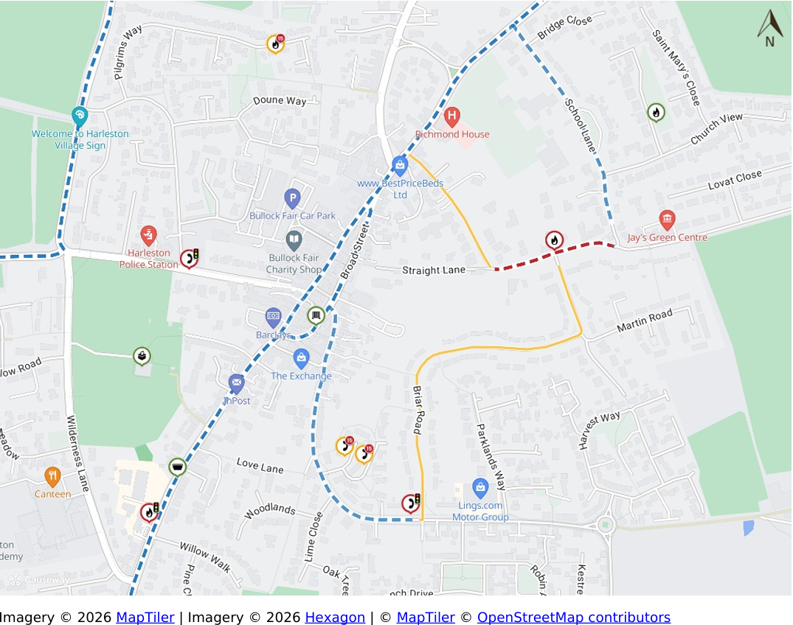

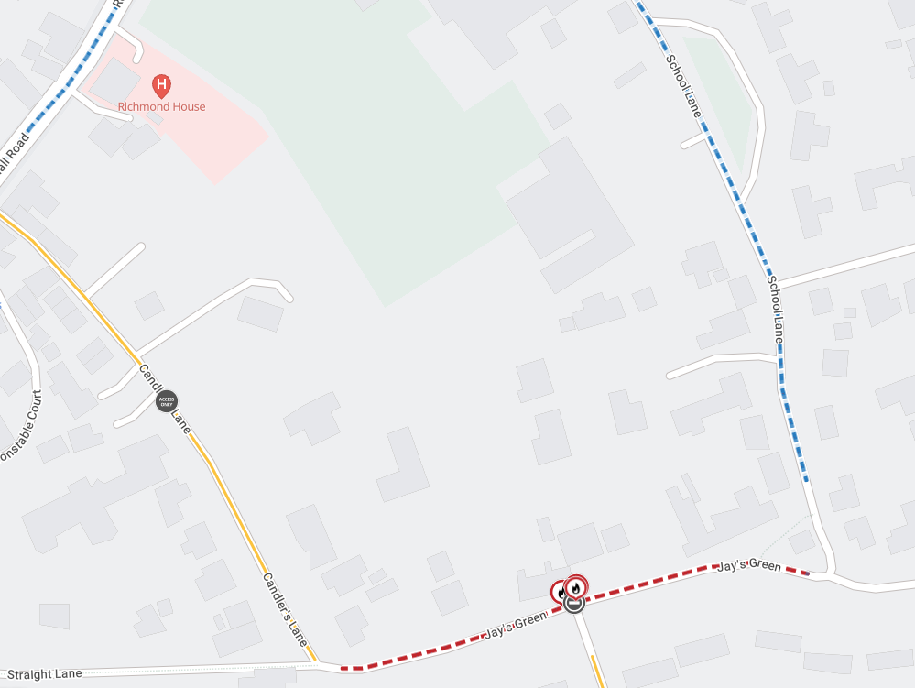
ROAD B)
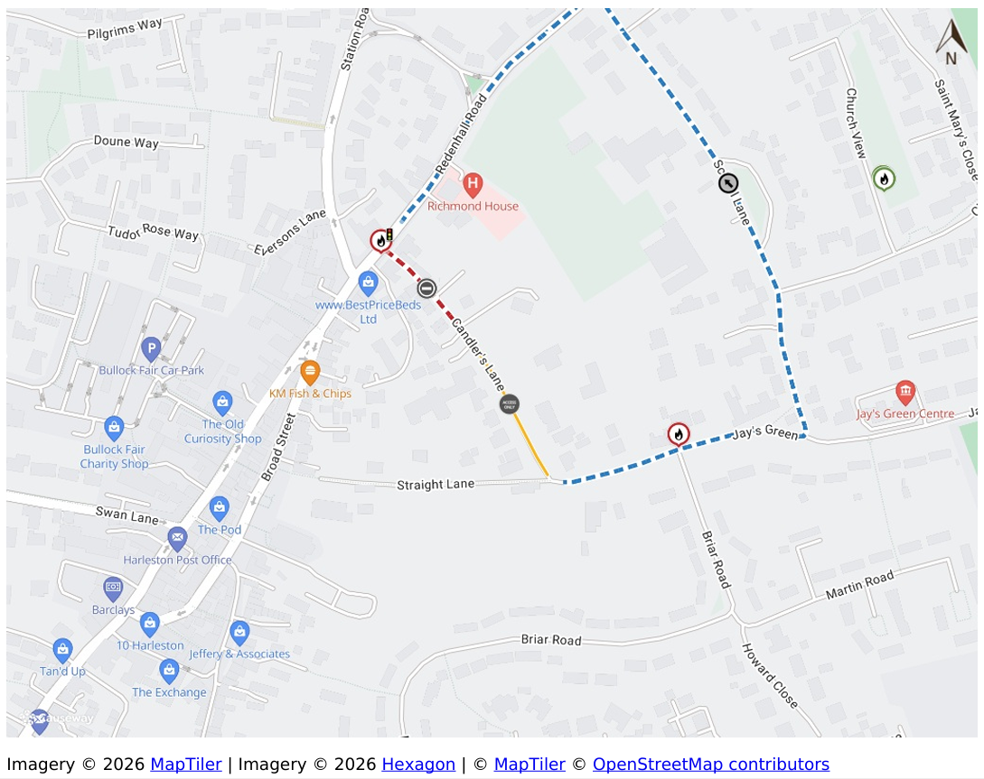
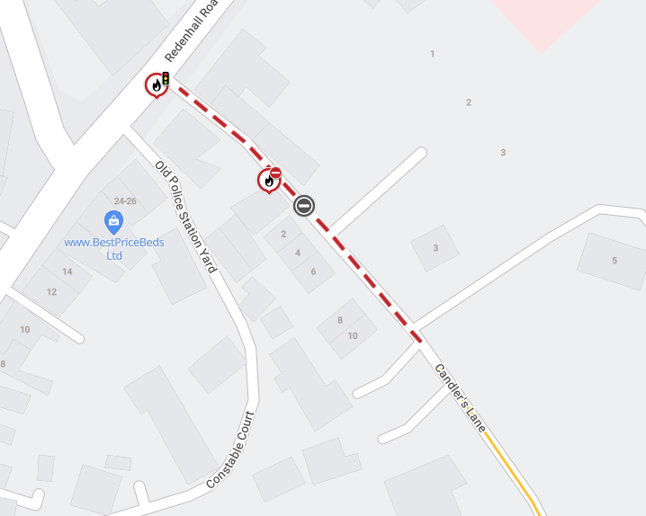
ROAD C)
